LINUX COMMANDS

- Create user with name Techie and provide sudo access to user.
Ans: Open terminal and Create user and Enter password then successfully created to check id
username then enter we get details of new user like id, groups, owners.

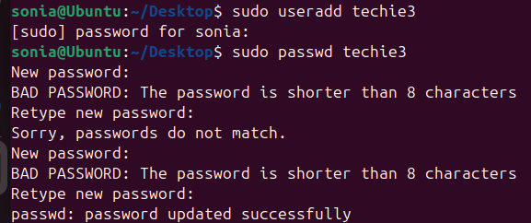

- Navigate to the home directory.
Ans: Open terminal and use the command to change directory to home (cd ~).
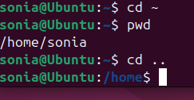

- Create a new directory.
Ans: mkdir directory name to create new directory.
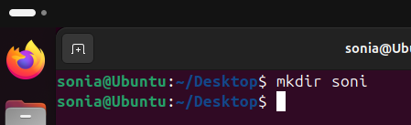
- List the contents of a directory.
Ans: Use the command (ls) to display the contents of the current directory

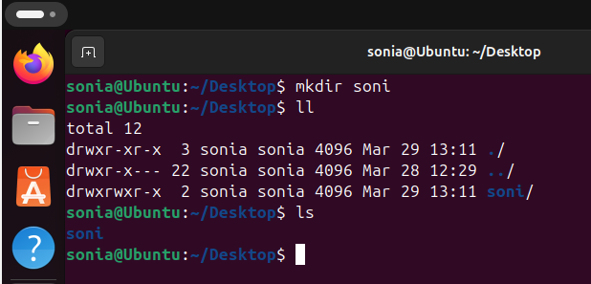

- Change the current directory.
Ans: Use the command cd directory_name to change the current directory
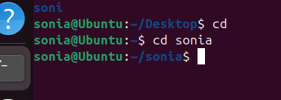

- Create a new empty file.
Ans: Use the command touch file_name to create a new empty file.

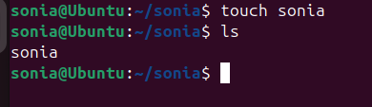

- View the contents of a file.
Ans: Use the command cat file_name to display the contents of a file
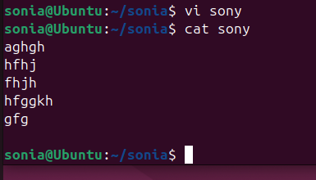
- Copy a file to another location.
Ans: Use the command cp source_file destination_path to copy a file.
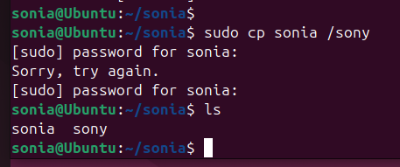
- Move a file to another location.
Ans: The file "desk" is successfully found in the /tmp directory using the ls command.
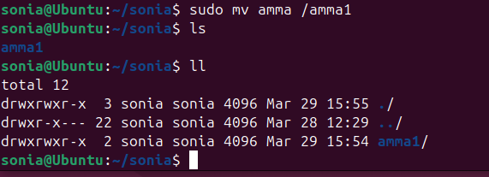

- Rename a file
Ans: The file name changes from desk to new desk in the directory
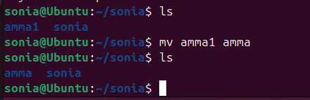

11) Delete a file.
Ans: Use the command rm file_name to delete a file
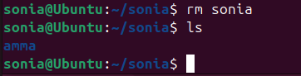
12 ) Grant or revoke permissions on a file or directory.
Ans: Use the command chmod 755 Devops to change permissions.
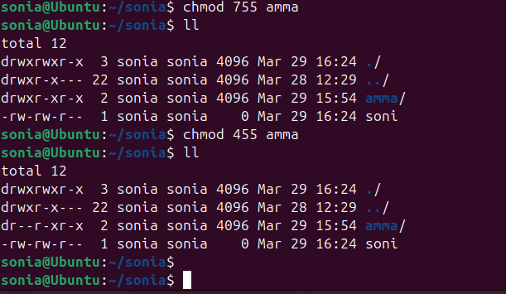

- View the current date and time.
Ans: Use the command date to display the current date and time

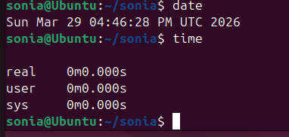
- Check the system uptime.
Ans: Use the command uptime to check how long the system has been running.
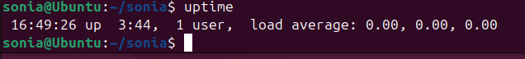

15) View the running processes.
Ans: Use the command ps aux to display all running processes in the system.
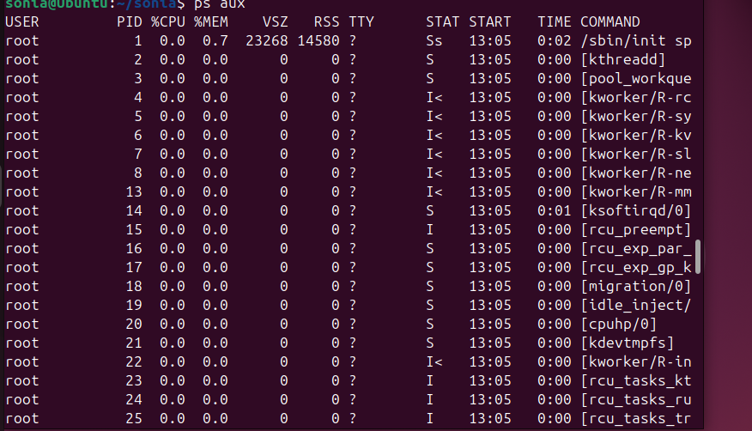
16) Kill a running process.
Ans: Use the command kill process_id to terminate a running process or Kill -9 process id.

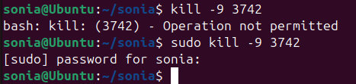

17) Install a package using the package manager (e.g., apt or yum).
Ans: Use the command sudo apt install nginx to install a package

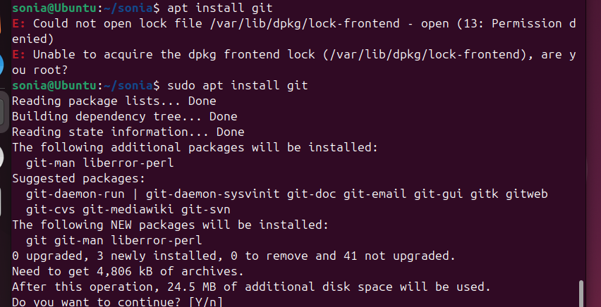

- Update the system packages.
Ans: Use sudo apt update && sudo apt upgrade -y to update packages.
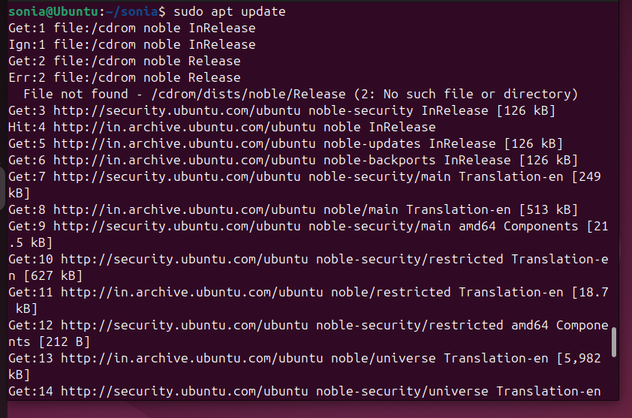
- Create a symbolic link.
Ans: Use the command ln -s target_file link_name to create a symbolic link.
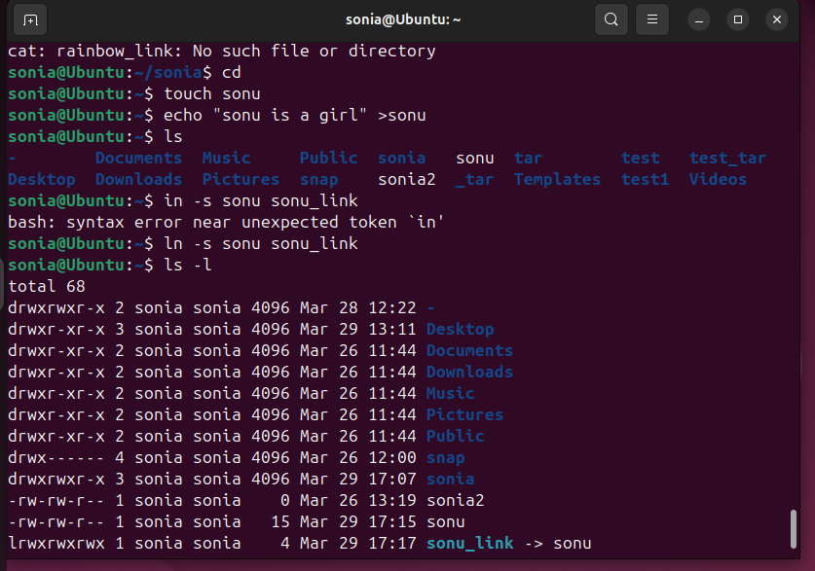
- Search for files using the find command.
Ans: Use the command find path -name file_name to search for files in a directory
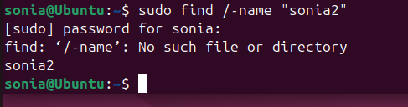

- Compress and decompress files using tar.
Ans: Use the command tar -cvf archive_name.tar folder_name to compress the folder.

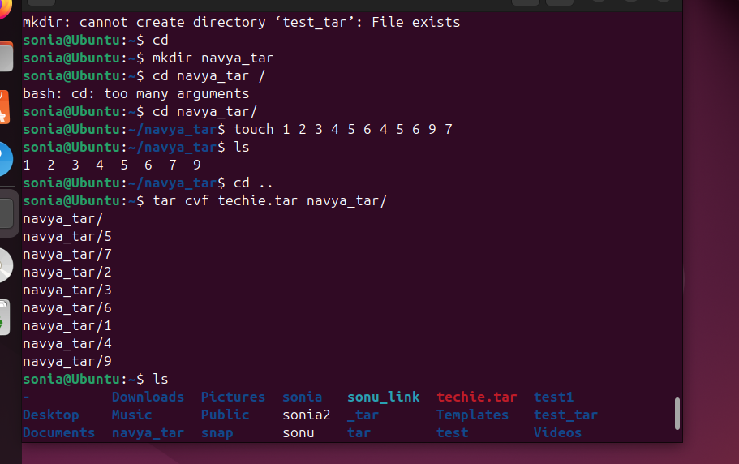

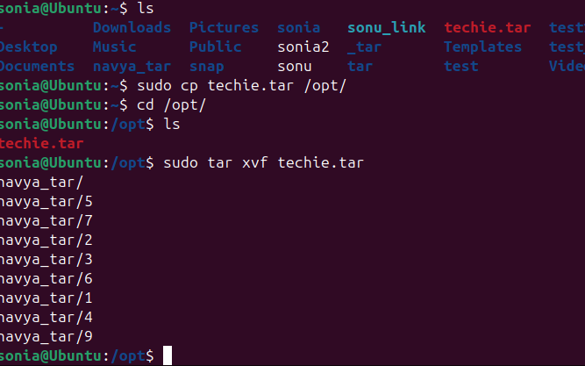
- Monitor system resources with top or htop.
Ans: Use the command top to monitor system resources in real-time.

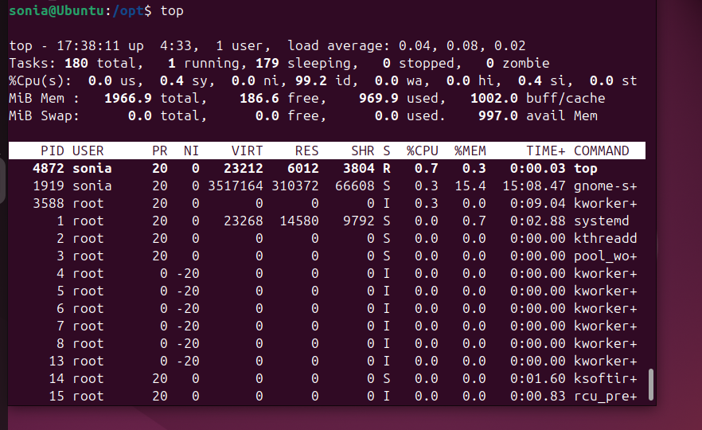

23)Create and manage user groups.
Ans: Create a group and add a user to the group.
• groupadd devteam
• usermod -aG devteam techie 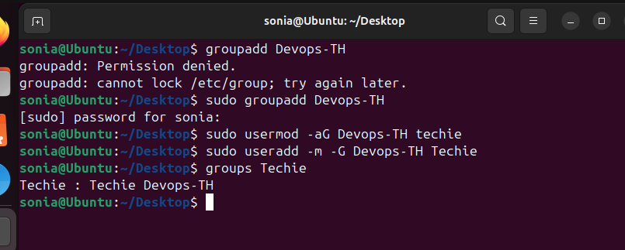

24 Set up SSH password less authentication.
Ans: SSH login works without password.
• Generate SSH key using ssh-keygen.
• Accept default file path.
• Copy public key to remote system using ssh-copy-id.

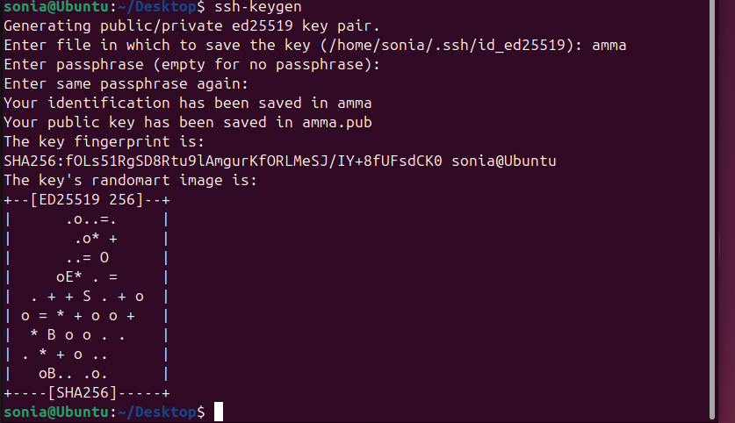
- Monitor log files using tail or grep.
Ans: Use tail -f file_name to monitor file updates in real-time and Modify the file to observe live changes.
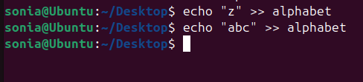
- Set up a web server (e.g., Apache or Nginx).
- Install Nginx using package manager.
2. Start and enable the Nginx service.
3. Access the web server using browser

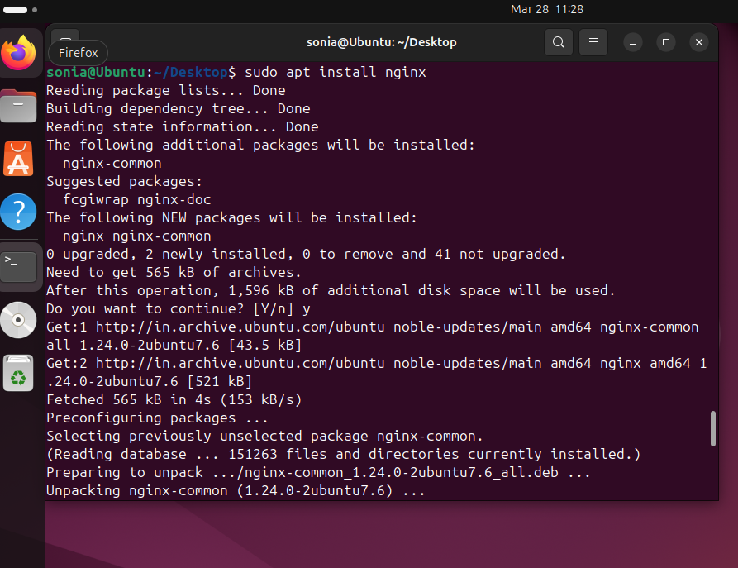
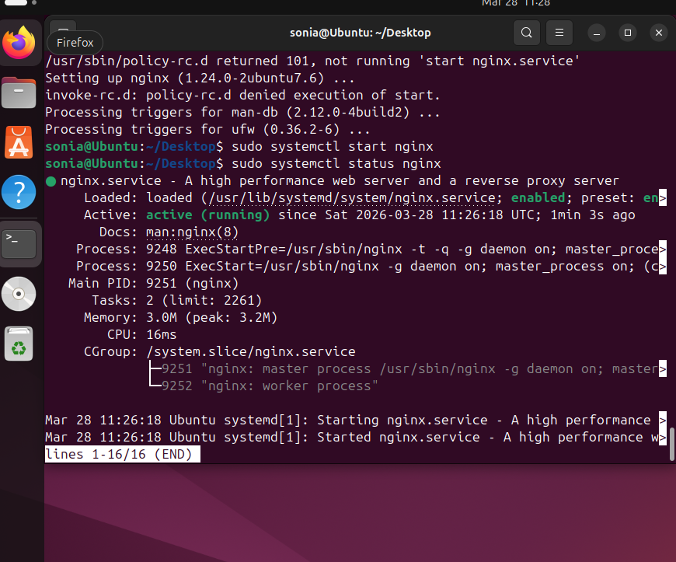
- Configure and secure a MySQL Database.
Ans: Steps to Secure MySQL Database
• Install MySQL server.
• Start and enable MySQL service.
• Configure security settings.
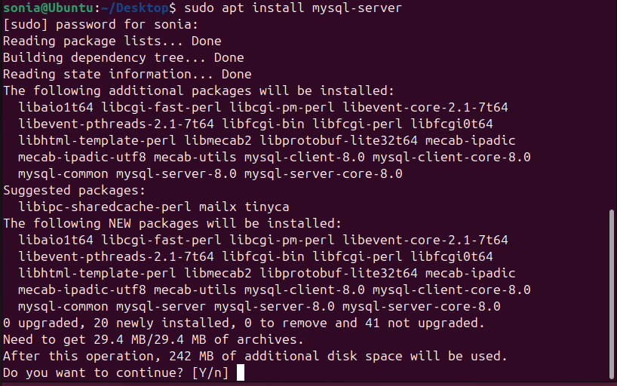
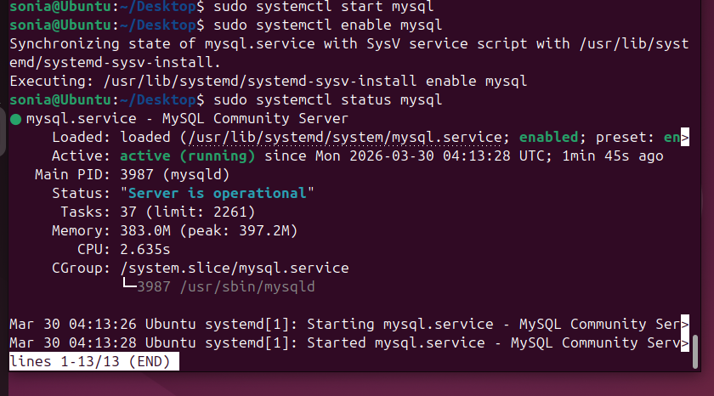

28) Set up a Application Server (e.g.,Apache Tomcat)
Ans: Steps:
• Install Apache server.
• Start and enable the service.
• Access the server through browser.

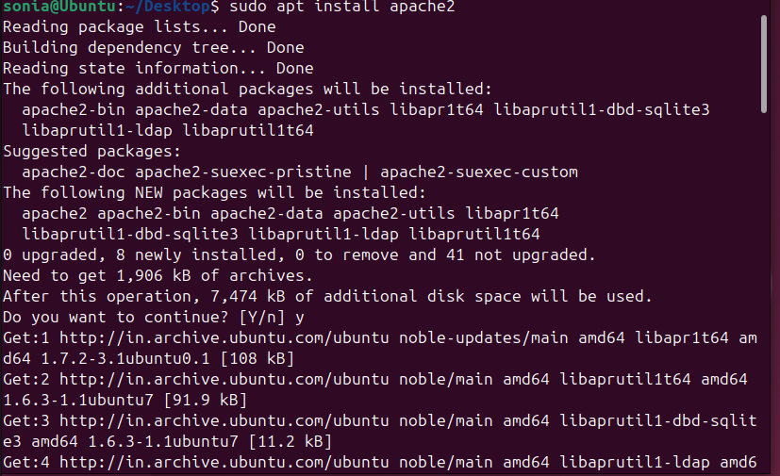
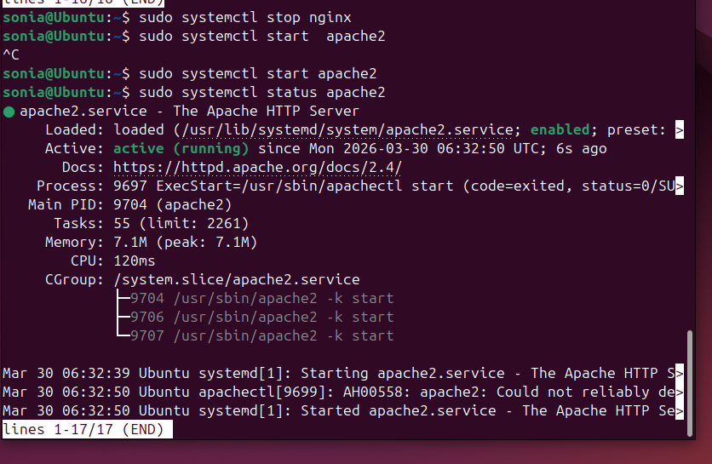
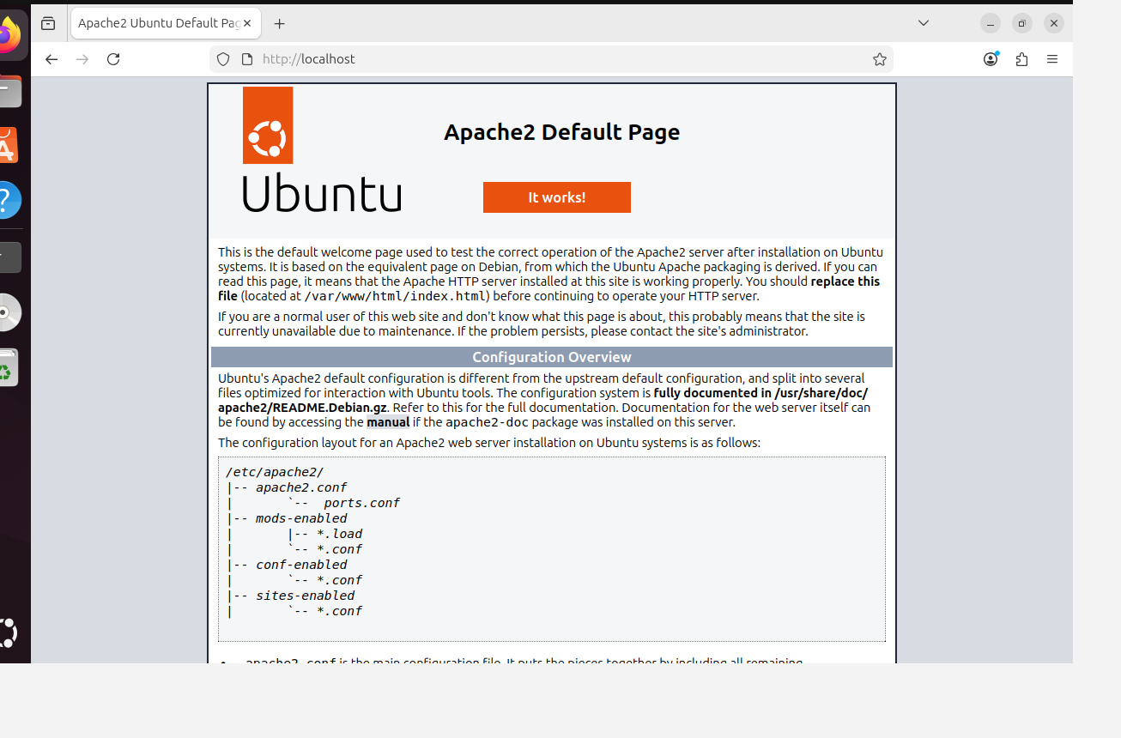
29)create a service file for Apache Tomcat.(Should execute by using systemtctl command)
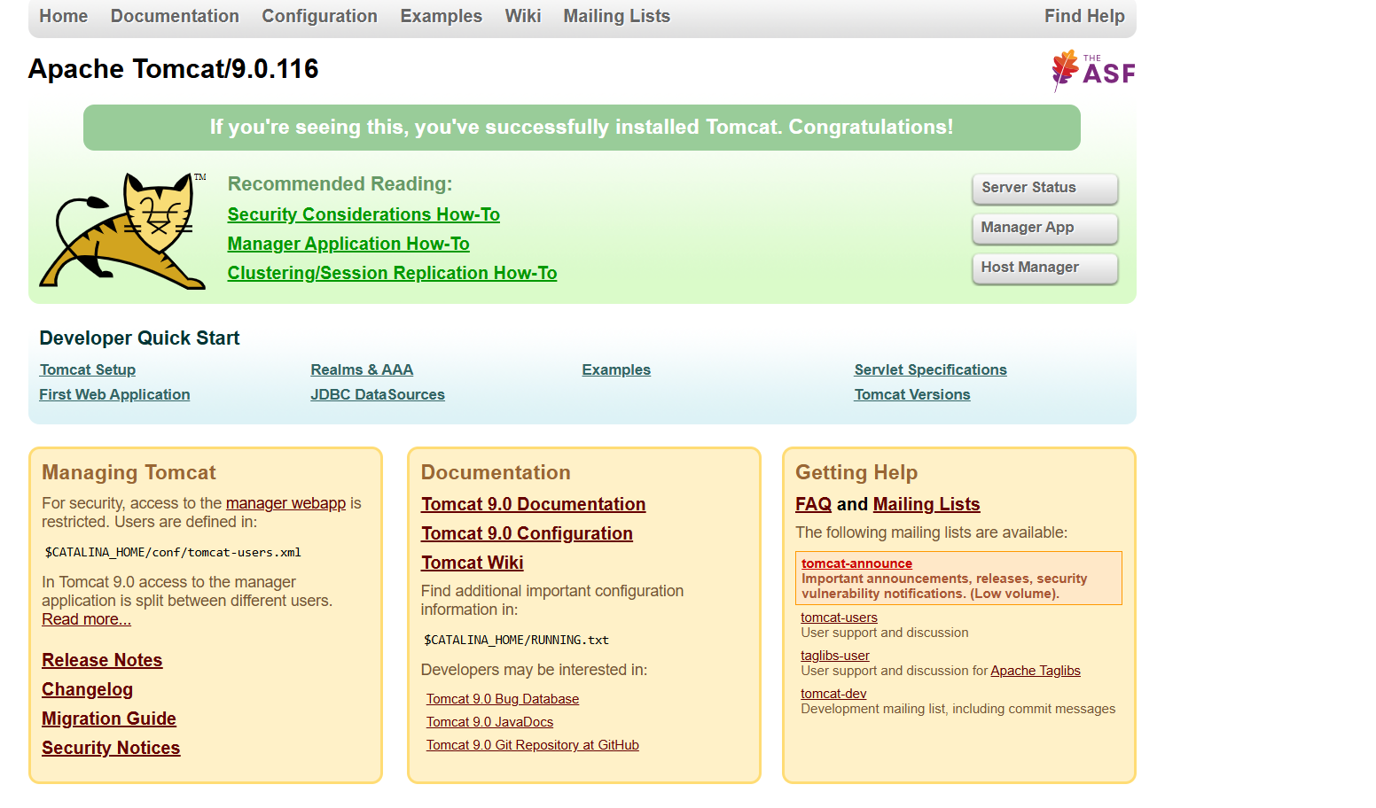
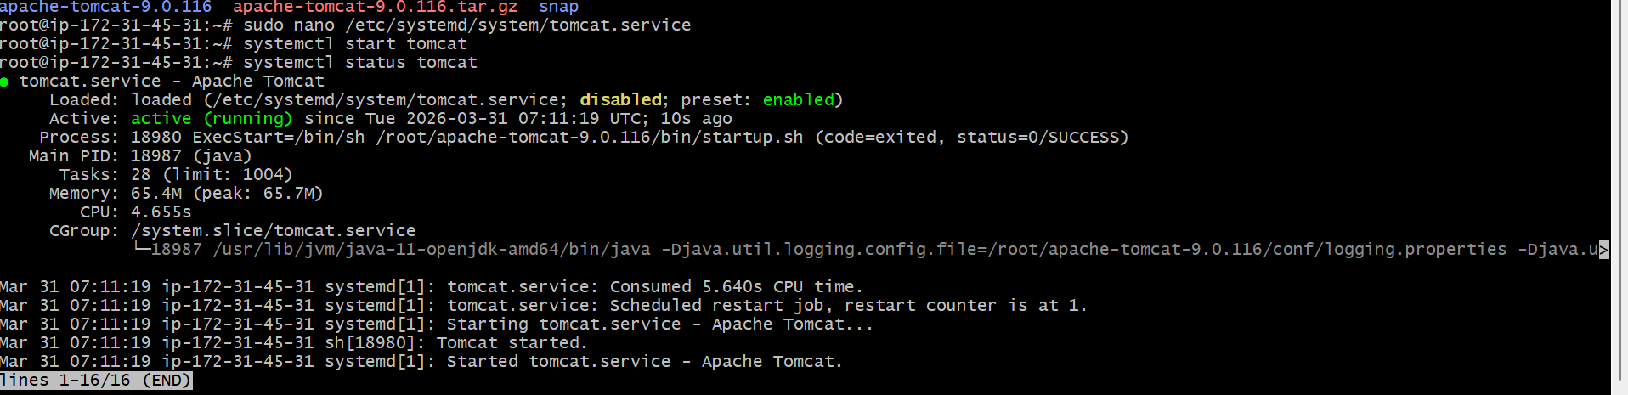

- Print specific columns from a delimited file.
Ans: The awk command successfully prints selected columns from the file. Only specified columns are displayed in the outp
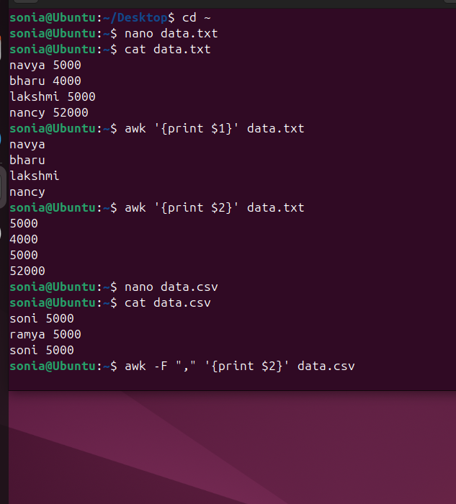
31) Filter and print lines based on a specific pattern or condition.
Ans: 1. Use grep to filter lines based on text pattern.
2. Use awk to filter lines bas

32)Calculate and print the average, sum, or other statistics of a column.
Ans: Use awk to calculate sum and average of a numeric column.
• awk '{sum += $2} END {print "Sum:", sum}' test
• awk '{sum += $2; count += 1} END {print "Average:", sum / count}' test

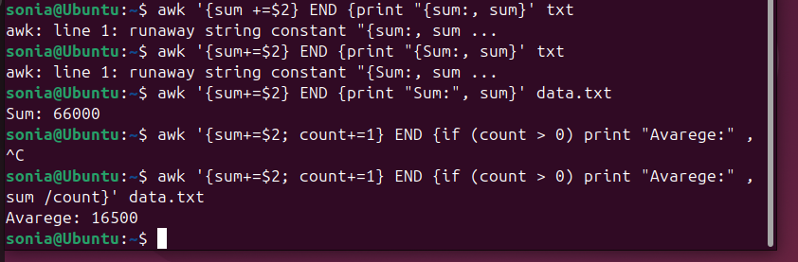
- Perform string manipulation, such as extracting substrings or changing case.
Ans: The sed command successfully replaces specific strings in the file.

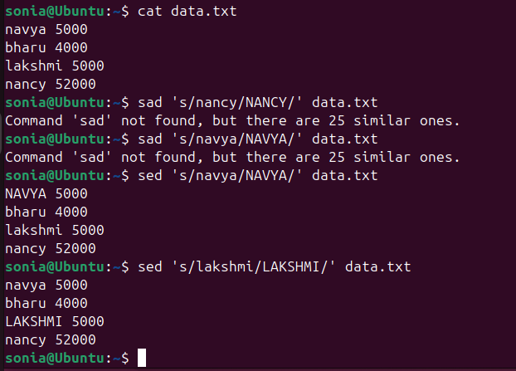
- Count the occurrences of a specific pattern in a file.
Ans: Use grep -c "pattern" file to count occurrences

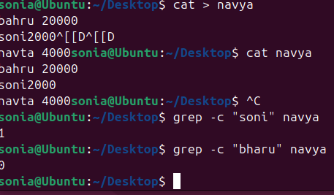
- Sort lines based on a specific field or column.
Ans: Use the sort command with column options to sort data based on a specific field.

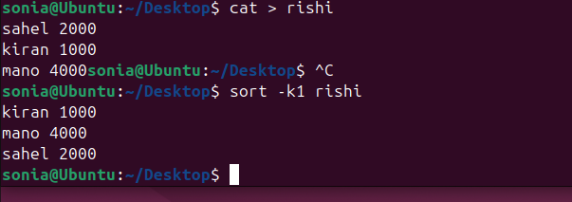
- Merge multiple files based on a common field or column.
Ans: 1. Create two files with a common column.
2. Sort both files.
3. Use join command to merge them.
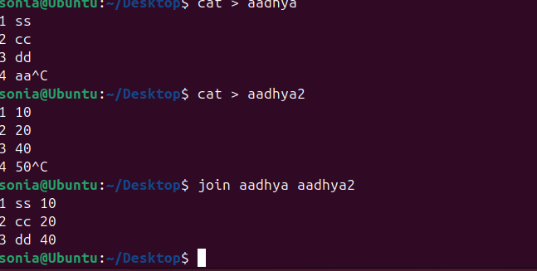
- Substitute text in a file using search and replace.
Ans: Use the sed command to search and replace text in a file.


- Delete specific lines based on a pattern or line number.
Ans: Use the sed command to delete lines either by pattern or by line number.

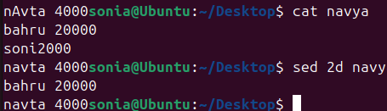
- Append or insert text before or after a specific pattern or line.
rn.Ans: Steps for before and after text pattern
• Use sed '2i text' file to insert before a line.
• Use sed '/pattern/a text' file to append after a pattern

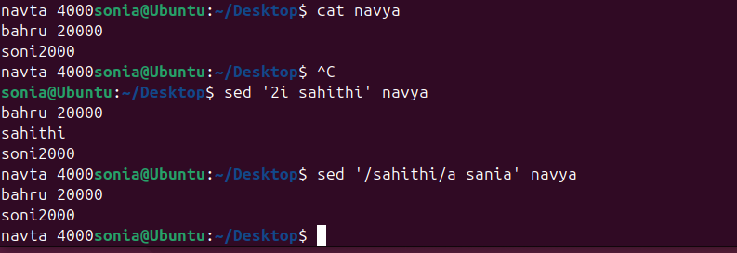

- Print only specific lines from a file.
Ans: In two ways for specific line to print
Use sed -n 'line_numberp' file to print a specific line.
Use sed -n 'start, endp' file to print a range of lines.

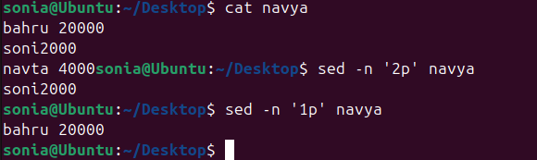
- Copy file from linux to windows machine
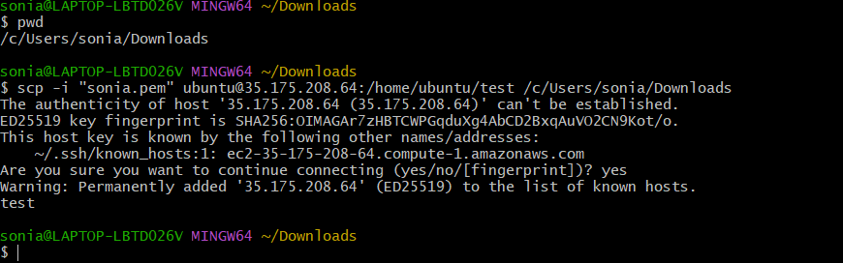

42)use cases for AWK and 5 use cases for sed
Ans: AWK and SED are powerful text-processing tools used for filtering, formatting, and
modifying data in Linux systems.
1. Insert text
• Add text before a line
sed '2i text' file

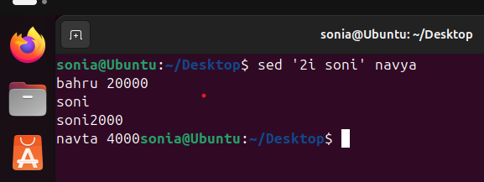
2. Print specific lines
• Display selected lines
sed -n '2p' file

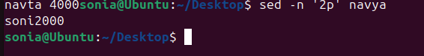
3. Perform calculations
• Calculate sum, average, etc.
awk '{sum+=$2} END {print sum}' file


4. Print specific columns
• Extract particular columns from a file
awk '{print $1, $2}' file

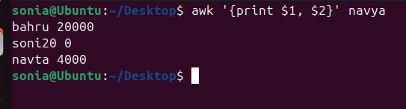
5. Perform calculations
• Calculate sum, average, etc.
awk '{sum+=$2} END {print sum}' file

